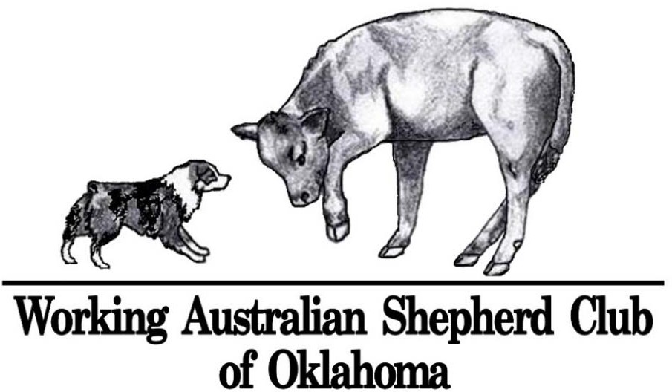
WASCO Spring Fling May 8- 9, 2021 Broken Arrow, OK
4 Stockdog Trials and 4 Conformation Shows

at Mindy Stevenson/Latigo Farm - 27560 E 77th St S, Broken Arrow, Oklahoma 74014 www.latigofarm.net
Contact Mindy during show (918) 557-2349
ASCA Sanction Pending. Pre‐entries open March 21, 2021, close April 28, 2021 by postmark date. Make checks payable to WASCO.
Mail all entries to Barbara Jeleski, 9043 E 29th St, Tulsa, OK 74129-6803 (918) 625-5874, agilitymom@sbcglobal.net

4 ASCA Stockdog Trials

Course Director – Mindy Stevenson (918) 557-2349, mshorse@valornet.com Entry Clerk & Trial Secretary – Barbara Jeleski
started, open, advanced, jr working handler, novice handler and FEO divisions on each class of stock
trials will run concurrently maximum of 50 combined runs per trial
run order will be drawn prior to trial, bitches in season will run in draw order
judges Sat AM & Sun PM – John Knepper (TX) cattle & sheep, Russ Ford (TX) ducks
Sat PM & Sun AM – Russ Ford cattle & sheep, John Knepper ducks

Class | Pre‐Entry | Jr Pre- Entry | After 4/28 or Day of Show Entry | Courses
3-5 Cattle, ~400lb angus x calves | $50.00 | $45.00 | $55.00 | B course Sat & H course Sunday- Both clockwise w/set out
5 Ducks, khaki/call crosses | $30.00 | $20.00 | $40.00 | B course Sat & H course Sunday - Both clockwise w/set out
3-5 Sheep, hair breed crosses | $40.00 | $30.00 | $50.00 | B course Sat & H course Sunday - Both clockwise w/set out
Arena Trial Schedule each day 6:45am-7:15am Check‐In/Move‐Ups/Gate Entries if available – for both AM & PM trials 7:30am Handler’s Meeting, Trial starts immediately after Handler’s Meeting
TRIAL AWARDS: Ribbons for Qualifying Score and 1st thru 4th Class Placement
Rosettes for High in Trial for each Division, High in Trial Aussie, High in Trial Other Breed and High Scoring Junior Handler WEEKEND AWARDS (must be entered in all trials/all stock to be eligible for awards): Awards for Aussies Only High Combined WTCH, non-WTCH and MPS (2 highest STD scores from each stock), Award for High Combined Other Breed
4 ASCA Conformation Shows

Entry Clerk – Barbara Jeleski (918) 625-5874, agilitymom@sbcglobal.net
Show Secretary – Cathi Morris (918)-850-2496 cathimorris54@gmail.com
NO ELECTRICITY! Casual dress. Porta‐Potty only, no bathrooms or changing rooms available on site. Outside on grass.
No specific Grooming area, please clean up all hair around your dog’s grooming area
Regular & Non-Regular Conformation Classes Offered and will run in order listed:
Non‐Regular Junior Showmanship – Pee‐Wee (3 to under 6 yrs), Sub‐Junior (6 to under 8 yrs)
Regular Junior Showmanship – Novice Junior (8‐12 yrs), Open Junior (8‐12 yrs), Novice Senior (13‐17 yrs), Open Senior (13‐17 yrs) Non‐Regular Puppies – 2‐4 and 4‐6 classes, divided by sex. Winners of each class to compete for BOB puppy and BOS puppy
Non‐Regular Veterans – 7 to under 10 yrs and 10+ yrs classes, divided by sex. Winners of each class to complete for Best Veteran
Regular Altered/Intact – 6‐9, 9‐12, 12‐15, 15‐18, Novice, Am Bred, Bred By, Open Blue Merle, Open Red Merle, Open Black, Open Red
Class | Pre‐Entry | After 4/30 or Day of Show Entry | Weekend Discount, pre-entry only
All Junior Showmanship | $5.00 | $8.00
Non-Regular Puppies and Veterans | $8.00 | $10.00 | $28.00 for all 4 non-regular shows
Altered | $15.00 | $18.00 | $50.00 for all 4 altered shows
Intact | $18.00 | $22.00 | $60.00 for all 4 intact shows
Conformation Schedule *consecutive shows start the later of posted time or 15 minutes after end of previous show
Saturday 11:15am-11:45am Check‐In/Move‐Ups/Gate Entries for all shows
12:00pm show ASCA Senior Breeder Judge – Heidi Mobley of Krum, TX
2:30pm* show ASCA Senior Breeder Judge – Trisha Herring of Blanchard, OK
Sunday 8:15am-8:45am Check‐In/Move‐Ups/Gate Entries for both shows 9:00am show ASCA Provisional Breeder Judge – Mirjam Senger of Villa Ridge, MO
11:30am* show AKC Judge – Carolyn Herbel of Putnam, OK
SHOW AWARDS: Ribbons for 1st thru 4th Class Placement. Rosettes for Best Junior, Reserve Junior, Best Puppy, Best Veteran, Winners, Reserve Winners, Best of Breed, Best of Opposite Sex and Best of Winners
VOLUNTEER WORKERS ARE APPRECIATED! Earn free WASCO club membership. Check out our worker raffle baskets.

COVID-19 STATEMENT: All State and Local COVID-19 regulations will be followed. As this is a fluid situation, please check the latest information here:
https://wedc.org/wp-content/uploads/2020/05/WEDC_COVID-19-Outdoor-Recreation-Guidelines.pdf
Competitors showing any symptoms or with relatives showing symptoms must stay home and not participate in events. People who test positive or have relatives
who test positive for coronavirus should follow state and local quarantine rules. Entry fees will be refunded for any COVID-19 related cancellations.

FOOD & BEVERAGES: Saturday and Sunday lunch TBA pending Covid restrictions: Be prepared to bring your own
LODGING: Please act responsibly! Do not leave dogs unattended at motels. Do not bathe or groom dogs in motel rooms.
La Quinta Inn & Suites (918) 615-3400, 451 W. Albany St, Broken Arrow, OK 74012 PLEASE SUPPORT ASCA PARTNERS
Red Roof Inn Tulsa (918) 622-6776, 4717 S. Yale Avenue, Tulsa, OK 74134 PLEASE SUPPORT ASCA PARTNERS
Clarion Hotel (918) 258-7085, 2600 N. Aspen, Broken Arrow, OK, US, 74012, Fax: (918) 251-6768 http://www.clarionoftulsa.com
Homewood Suites (918) 392-7700, 4900 W. Madison Place, Broken Arrow, OK 74012 (Garnett & 71st)
Aloft Tulsa (918) 949-9000, 6717 S 104th E Ave., Tulsa OK 74133 (no deposit if you sign waiver). Staybridge Suites (800) 225-1237, 1111 E. 73rd Street South, Tulsa, OK 74133 ($75 pet fee) Candlewood Suites (918) 294-9000, 1008 E. 74rd Street South, Tulsa, OK 74133
Days Inn (918) 665-6800, 8201 E. Skelly Drive, Tulsa, OK

DISASTER AND EMERGENCY PLANS FOR PEOPLE AND DOGS AT THIS EVENT
DOG INJURY/VET: Jennifer Patton, DVM from Advanced Care Veterinary Hospital 12226 Heywood Hill Road Sapulpa, OK 74066 (918) 224-1900 www.advancedpetvet.com Directions to the Vet Hospital Exit South off E Taft Ave in Sapulpa onto Heywood Hill Rd PEOPLE AID/PERSONAL INJURY OR HEALTH PROBLEMS: Dial 911 for the Emergency Response Team/Ambulance.
Fire Department and EMSA – (918) 259-8660 Police Department – (918) 451-8844
St John’s Hospital, 1000 W Boise Cir, Broken Arrow, OK 74012 (918) 994-8000 (Directions to the hospital available on site) First Aid Kit for minor injuries will be at the event site.
FIRE: Dial 911. All dogs should be crated or leashed securely. Owners, Handlers and Spectators must keep the main driveway clear so emergency vehicles will have suitable access to the property.
THUNDERSTORMS & LIGHTNING: Should lightning be observed, all personnel and animals should move or be moved to the safety of their vehicles or covered buildings until the danger has passed.
MASS DISASTER PLAN - TORNADO: In the event of a tornado, dogs should be leashed and all people and their dogs should proceed to the lowest point on the property until the danger has passed.

GENERAL
- This trial will be held under the current rules and regulations of ASCA will be run under ASCA rules and regulations (http://www.asca.org/home/business‐office/rules‐forms/).
- All ASCA recognized herding breeds are welcome in the Farm and Stockdog Trials.
- To receive title certifications, each non‐ASCA registered dog will be required to have an ASCA Tracking Number (http://www.asca.org/wp‐content/uploads/sites/35/2016/04/trackapp.pdf).
- WASCO reserves the right to substitute a judge, if necessary.

RESPONSIBILITIES
- Owners/handlers are responsible for their dog(s). Dogs must be crated or on lead at all times, except when competing.
- WASCO, its’ officers and members, ASCA, its Board of Directors and the property owner assume no responsibility for any loss, damage or injury sustained by an exhibitor, handler, dog, property, child or spectator. Knowing this, you assume full liability for yourself, your dog and any minors under your control and accept full responsibility for any damage caused by you and/or your dog.
- The show site will open at 6:30am each day and close following judging each day. No dogs may be left at the show site overnight.
- There are designated exercise areas. Please clean up after your dogs!
- Please respect the grounds and clean up after yourself and your dogs to maintain the premises in a clean and tidy condition!
- If you would like a place to sit, please bring your chair.
- No alcoholic beverages are allowed at the event site.
- Bitches in season will run in draw order for the farm and stockdog trials but are not allowed to be crated by any ring or arena.

ENTRIES & FEES
- All entries must be on ASCA entry forms with proper fees included (http://www.asca.org/home/business‐office/rules‐forms/).
- Exhibitors, through submission of entry, acknowledge that they are knowledgeable of the ASCA Rules & Regulations. No entry shall be accepted which specifies any conditions as to its acceptance.
- Entries must have clearly visible USPS postmark. No meter mail allowed. No telephone, facsimile, email or incomplete entries will be accepted.
- Pre‐entries postmarked before March 21, 2021 will not be accepted. Pre‐entries close April 28, 2021.
- Entries received without proper signature, fees, information, post‐dated checks, etc. will be deemed incomplete and will not be accepted as valid entries. Entry fee must be paid by check, cashier’s check or money order with funds drawn on a US Bank.
- WASCO will deposit entry fees on or about May 3, 2021. Any checks returned for insufficient funds will be considered a void entry. There is a $50 service charge for returned checks. If entries are resubmitted, payment must be in the form of money order or cashier’s check.
- Cancellation of entries must be in writing and postmarked or emailed no later than April 28, 2021 to receive full refund. Refunds will be issued no later than May 17, 2021. No refunds will be given for cancellations made after close of pre‐entries unless run is filled from waitlist.
- No entry shall be accepted from a dog or handler disqualified from the ASCA Conformation program; a dog or handler disqualified from all ASCA programs; or a person not in good standing with ASCA.
- The entry limit will be accepted in postmark order. If the trial is full the dog will be put on a waitlist in order of receipt.
- Confirmation of entries will be made via e‐mail after entries close, on or about May 3, 2021.
- Entry fees will not be refunded in the event a dog is absent, disqualified by a judge, or barred from competition by the trial committee. Entry fees will be refunded if dog is excused in writing by a veterinarian.
- Entry fees will not be refunded if the show/trial cannot open or be completed due to riots, civil disturbances, fire and/or dangerous weather conditions, acts of God, public emergencies, acts of public enemy, strikes or other causes beyond the control of WASCO.

